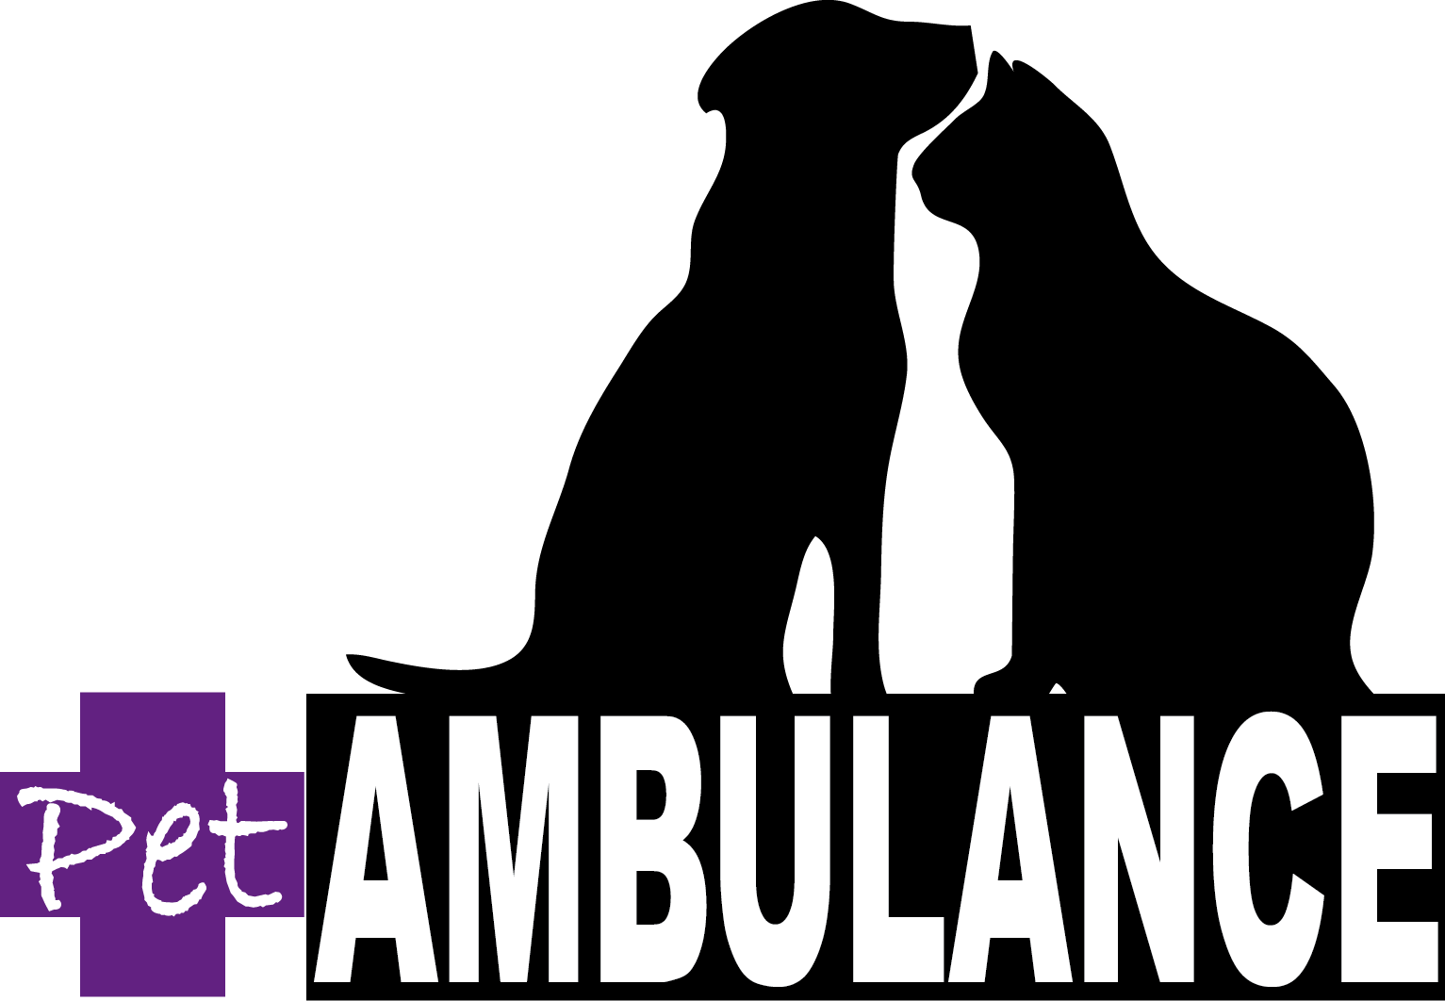
Get your pet to the vet with…
PET AMBULANCE SERVICES
Phone: 0448 789 039

ABN 37847590768

Transport Type | Business Hours (8am-5:30pm) Monday to Friday | Price – GST inclusive

Standard Transport | Business Hours | $170
Oxygen Transport | Business Hours | $210
Standard Transport (AH) | After Hours | $220
Oxygen Transport (AH) | After Hours | $260
Intubated/Intensive Care Transport | Business Hours | $320
Intubated/Intensive Care Transport (AH) | After Hours | $400
Consultation Transport  (appointment only) | Business Hours | $190

